

**Happiness Index Report 2022**

**An Explorative Data Analysis**





April 25, 2022

praxis business school

KOLKATA

**Contents**

1. Introduction

1.1. Overview

1.2. Research Objectives

1.3. Research Questions

2. Methodology

2.1. The Dataset

2.2. Ethical Considerations

2.3. Data Exploration

i. The Influence of Environmental Factors on One Another

ii. The Influence of Environmental Factors on the Happiness Ladder

2.4. Data Visualization

3. Results

4. Discussion

5. References

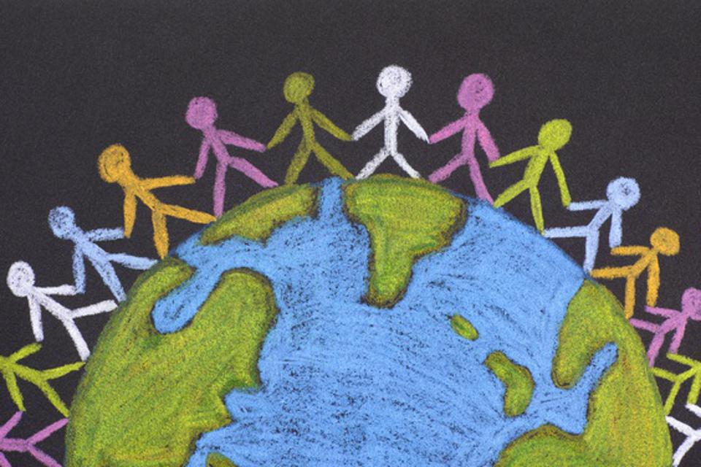

**1. Introduction**

**1.1 Overview**

Happiness is an emotional state characterized by feelings of joy, satisfaction, contentment and fulfilment. It is often described as involving

positive emotions and life satisfaction.

The World Happiness Report is an annual publication of the United Nations Sustainable Development Solutions Network. It contains articles, and rankings of national happiness based on respondent ratings of their own lives, which the report also correlates with various life factors. The report primarily uses data from the Gallup World Poll collected from people in over 150 countries

The World Happiness Report is a landmark survey of the state of global happiness. The report continues to gain global recognition as governments, organizations and civil society increasingly use happiness indicators to inform their policy-making decisions.

This term has been originated from the term “Gross National Happiness (GNH)” which was invented in 1972 and since then it has been the guiding principle of the government of Bhutan. In July 2008, GNH was also included in the constitution of Bhutan as a goal. GNH also served as a base of the UN Resolution “Happiness: towards a holistic approach to development” passed in 2011 and happiness was regarded as a fundamental human goal. The UN also issued the first World Happiness Report in 2012 and declared 20th March

as to be International Day of Happiness.

The rankings of national happiness are based on a Cantril ladder survey. Nationally representative samples of respondents are asked to think of a ladder, with the best possible life for them being a 10, and the worst possible life being a 0. They are then asked to rate their own current lives on that 0 to 10 scale. The report correlates the results with various life factors. Each variable measured reveals a populated-weighted average score

The Happiness Index prioritizes happiness over other factors like economic growth, GDP and it is measured by using following factors:

**1. Real GDP per capita-** It is the value of all the goods and services produced in a country in a given year divided by the total population of the country. This is a widely accepted way of measuring a nation’s wealth.

**2. Social support-** It is the perception of having a supportive social network and having people to depend upon in times of crisis. It raises the quality of life of an individual.

**3. Healthy life expectancy-** It is the estimate of the expected years of good health life of people at a age calculated by the World Health Organization (WHO).

**4. Freedom to make life choices-** It is the opportunity and liberty to choose and act from at least two options without the influence of any external factor.

**5. Generosity-** Often regarded as a virtue, it is basically an act of giving or sharing with others or it can be an act of a good deed.

**6. Perceptions of corruption-** It is a measure of the level of corruption in a country, especially in the public sector.

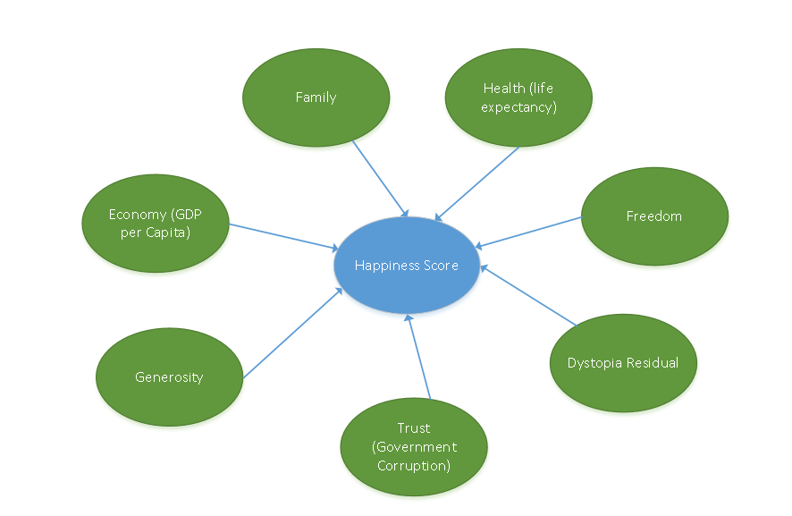

**Fig 1-**

The rankings of happiness are based on the Cantril ladder survey and it lies in the range of 0-10 (10 being the best and 0 being the worst). All the nations’ happiness index is then compared, and they are positioned according to their value of index. According to the 2022 World Happiness Report, India is on the 136th position out of 146 countries with a happiness score of 3.777. The values of individual factors are as follows:

1. Real GDP per capita- 1.167

2. Social support- 0.376

3. Healthy life expectancy- 0.471

4. Freedom to make life choices- 0.647

5. Generosity- 0.198

6. Perceptions of corruption- 0.123

**Fig 2- Happiness Score representation of India in 2022**

**1.2 Research Objectives**

The objectives of the study are as follows:

1. To understand the concept of Happiness Index.

2. To analyse World Happiness Report system as a measure to happiness among nations across the world.

3. To evaluate parameters of the happiness index.

4. To analyse possible reasons for India’s declining rank in World Happiness Report and propose strategies to improve the same.

**1.3 Research Questions**

1.What is happiness index?

2. What is the origin of this index?

3. What are the various factors affecting the index?

4. What role does happiness index play in present scenario?

5. How is happiness index measured?

6. Why is happiness index a better measure of growth than GDP?

7. What is the relationship between GDP and happiness index?

**2. Methodology**

The research is mostly fundamental and descriptive in nature. It includes both quantitative evaluation as well as qualitative understanding of the concept. Past trends are observed, graphs and charts are constructed accordingly to understand the future possibilities. Online data available on websites related to world happiness report along with several relevant research papers and articles have been studied to come to a conclusive analysis. Various parameters related to the happiness index have been segregated under relevant heads for conceptual clarity of the paper.

**2.1. The Dataset**

We will use the UN’s World Happiness Report (WHR) datasets created over the years 2018 till 2022. The WHR data is created by taking the average per nation of data collected through the Gallup World Poll survey, which correlates demographic, economic, political, and social factors with real-world outcomes.

The Gallup World Poll (GWP) is conducted yearly in at least 153 countries with a random sample of at least 1000 respondents in each country. Our compiled dataset could be found here: <https://worldhappiness.report/>.

As for the Gallup World Poll—surveys are conducted on sample sizes of approximately 1000, depending on the size of the country and are done through telephone or face-to-face for developing countries. More can be found here: <https://www.gallup.com/178667/gallup-world-poll-work.aspx>.

We most point out that, as explained above, of this data is collected through surveys and is thus mainly subjective. That is, when we refer to happiness or corruption below, we mean the averaged person's perception of his or her own happiness or the averaged person's perception of corruption in the government or in businesses.

**Introduction to Dataset-**

We have total 147 rows with 7 feature.

- GDP per capita

- social support

- Health life expectancy

- freedom

- absence of corruption

- generosity

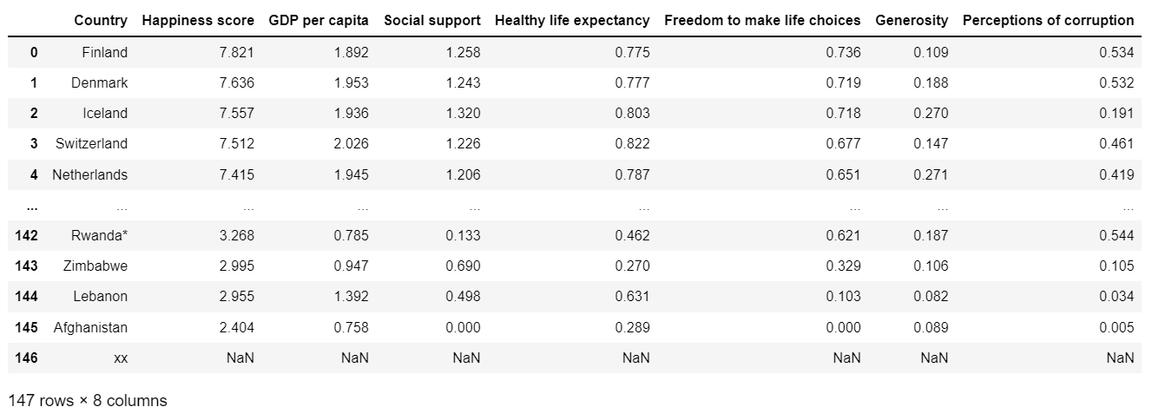

**Descriptive statistics-**

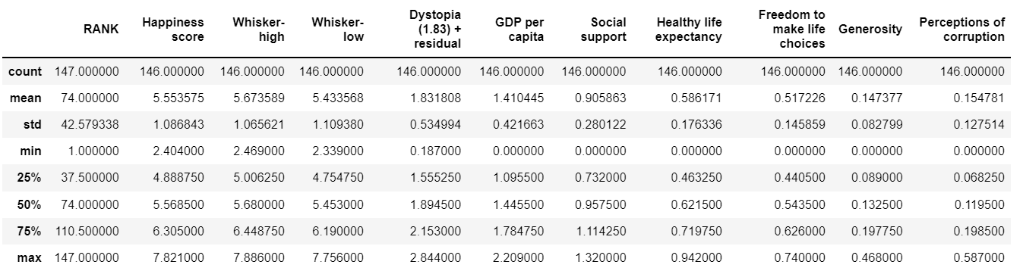

Average happiness score – 5.553

Median happiness score – 5.568

Maximum happiness score – 7.821

Minimum happiness score – 2.404

**2.2. Ethical Considerations**

In this project, we use the UN’s World Happiness Report (WHR) datasets created over the years 2018 till 2022. This data is created by taking the national average of the Gallup World Poll’s results. The Gallup World Poll (GWP) is conducted yearly in at least 153 countries with a random sample of at least 1000 respondents in each country. The survey is conducted over the phone in countries where most of the general population are phone users and face-to-face in others. All interviewees receive intensive training to ask questions in a non-leading manner and the interview is given in the languages most used in each country. The Gallup World poll is thus sufficiently representative of 95% of the world's adult population The WHR’s final features are all either measures of subjective experiences (e.g. positive affect and social support) or objectively recorded facts (e.g. GDP and healthy life expectancy at birth).

**2.3. Data Exploration**

**Fig 3-** **Happiness Score (India) across neighboring countries in 2022**

In this section, we are going to explore data with respect to our neighboring countries like China, Sri Lanka, Bangladesh and Pakistan. Among South Asian nations, India positions fifth in the happiness index. In a world setting, India positions 136th, far less than average. India may be one of the fastest growing economies of the world, but it is among the least happiest countries. Although India improved its position in the list compared to last year, it ranks lower than its neighbors, China being top in the list consistently. To quantify happiness across India and understand what makes people declare themselves happy in the Indian context, the firm measured happiness among Indians at both the macro (demographics) and micro (individual state of mind) levels.

**i. The Influence of Environmental Factors on One Another**

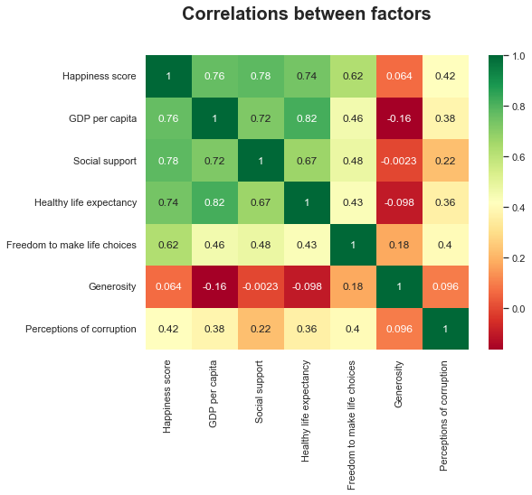

**Fig 4- Corelation Heatmap b/w factors**

**Corelation between factors-**

From the heatmaps, correlation coefficient between **GDP per capita, social support**,

**Healthy life expectancy** and **Happiness score** is 0.76 , 0.78, 0.74 respectively .it is indicating a strong positive relationship between **GDP per capita ,Social support , Healthy life expectancy** and the **Happiness score**. GDP is a tracker of the economic growth of a country. Hence, we conclude that the GDP of a country **social support**, **Healthy life expectancy** should be one of the top priorities to ensure **Happiness**.

The correlation between **perception of corruption** and **happiness score** is 0.42. This indicates a weak positive relationship between perception of corruption and the happiness score of a country.

**GDP** with **health life expectancy** has high correlation of 0.82 means they are highly corelated from this we can say that the countries that have high GDP per capita will have high life expectancy

**India and its neighbour-**

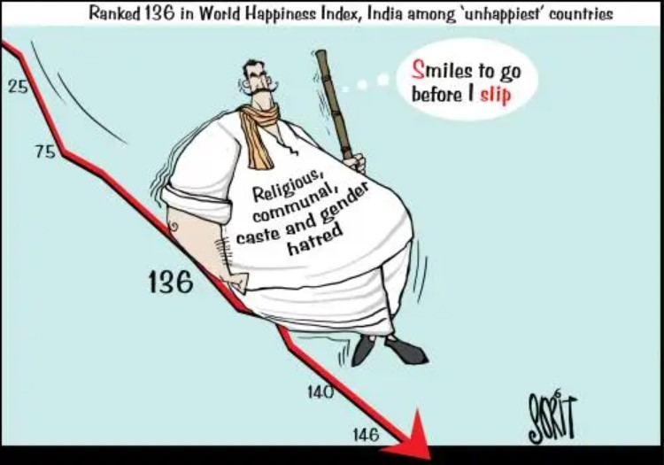

**Where does India’s GDP rank-**

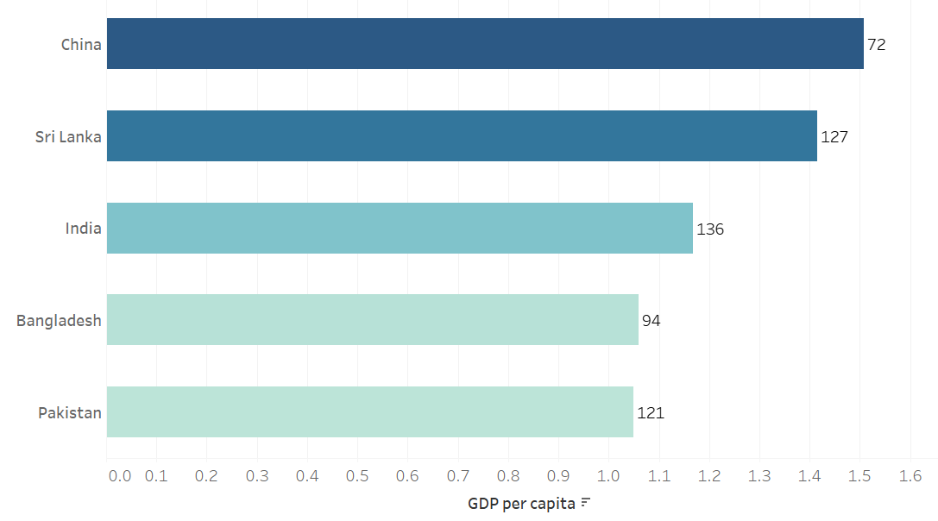

Although India has 3rd largest GDP per capita it stands last in its neighbour and India has less GDP per capita then Sri-lanka it doesn’t mean India have less GDP than Sri-lanka it is because population of India is so high that GDP per capita becomes low for India.

**Where does India’s Health Life expectancy rank-**

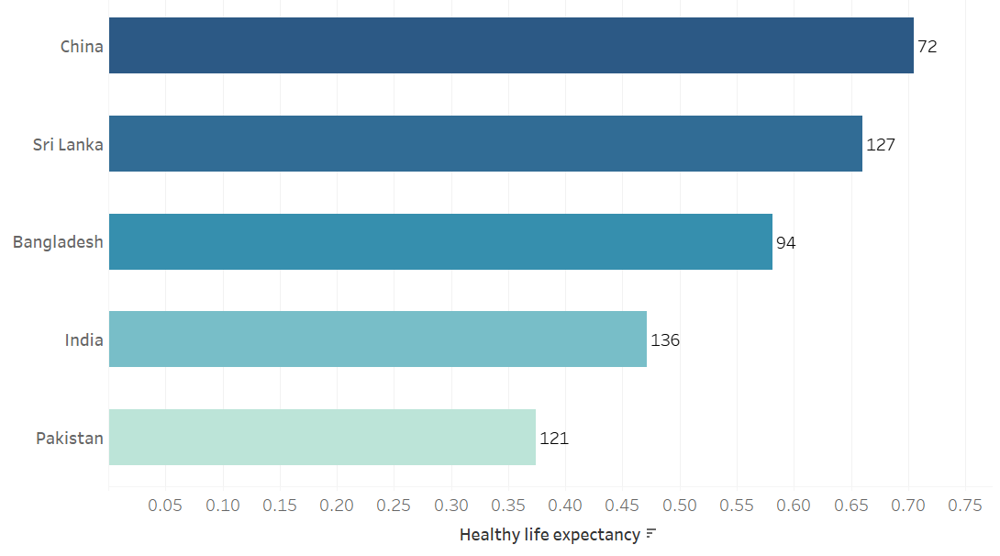

India rank 4th in health life expectancy b/w its neighbour although Pakistan has lower health expectancy but it stands ahead in world happiness.

**Where does India’s Generocity rank-**

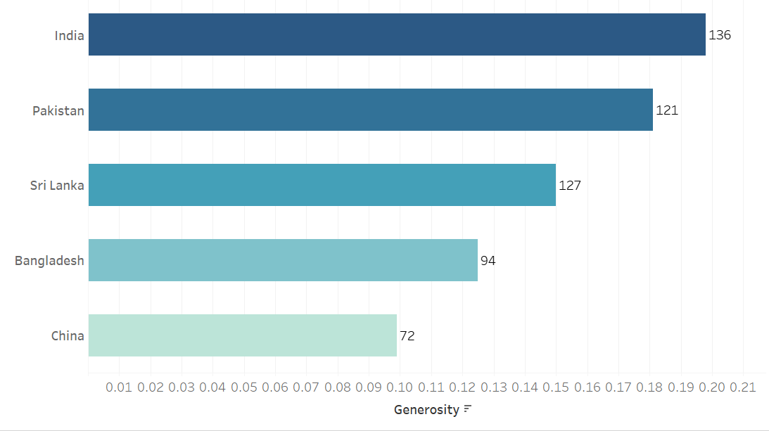

India has highest generosity among its neighbour and very high score as compare to China but India stands last in happiness index because it does not have huge impact on happiness score as GDP and health life expectancy has.

**Where does India’s Social Support rank-**

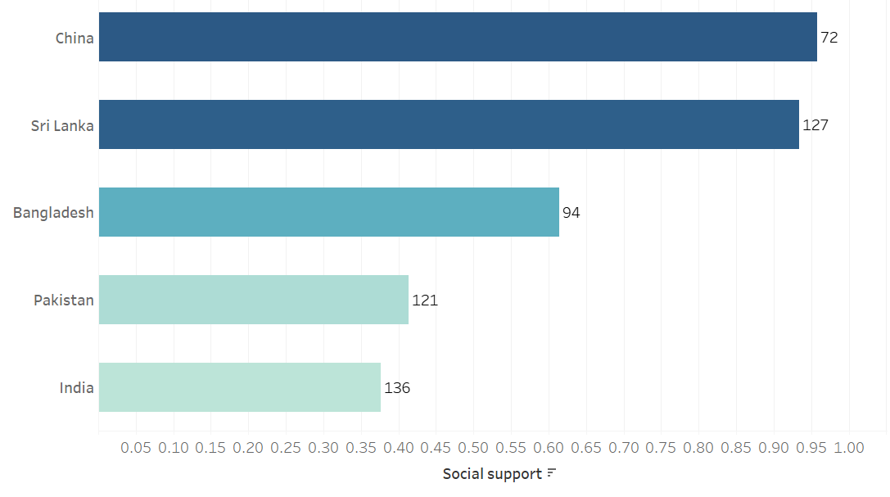

India has lowest social support that mean its people doesn’t help each other in difficult time or in time of crisis as compare to its neighbour.

**Overall comparison-**

As we have seen in corelation GDP social support and health expectancy has high corelation with happiness score and we can see that last 3 factor is almost same for all countries the deciding factor the 1st three which has huge impact on happiness factor.

**India with top 5 happiest country-**

India performance is very low as we compare it worlds top 5 happiest country we as India is fastest growing economy so we have to control population to increase GDP per capita we have to work all 6 sector to make India happy

**2.4. Data Visualization**

In this section, we will draw some visuals that will help you to get insights from the data.

**Fig 5-Line graph depicting various trends during 2018-2022**

**India’s GDP per capita Over the Years**

India’s GDP is gradually decreasing between 4 years i.e. 2018 to 2021 then there is drastic increase in GDP in 2022.

**India’s Social Support Over the years**

India’s social support is on a decreasing trend b/w 2018 to 2020 and there is drastic change in 2021 .in 2022 there is slight increment in 2022.

**India’s Health Life Expectancy Over the years**

An increasing pattern till 2019, yet there are distinct drops as found in the years 2020, 2021 with an unsurpassed low in the year 2021. This was due to covid 2019 now there is increment in health life expectancy.

**India’s Freedom to Make Life Choices Over the years**

An increasing pattern throughout the long term with a slight increasing pattern in 2022.

**India’s Generosity Over the years**

Generosity has come down in 2019 than it has increasing trend from 2019 to 2021 then it again decreased in 2022.

**India’s Perceptions of Corruption Over the years**

India’s perception of corruption is almost constant throughout these years. there not much significant change in perception of corruption.

**World at glance-**

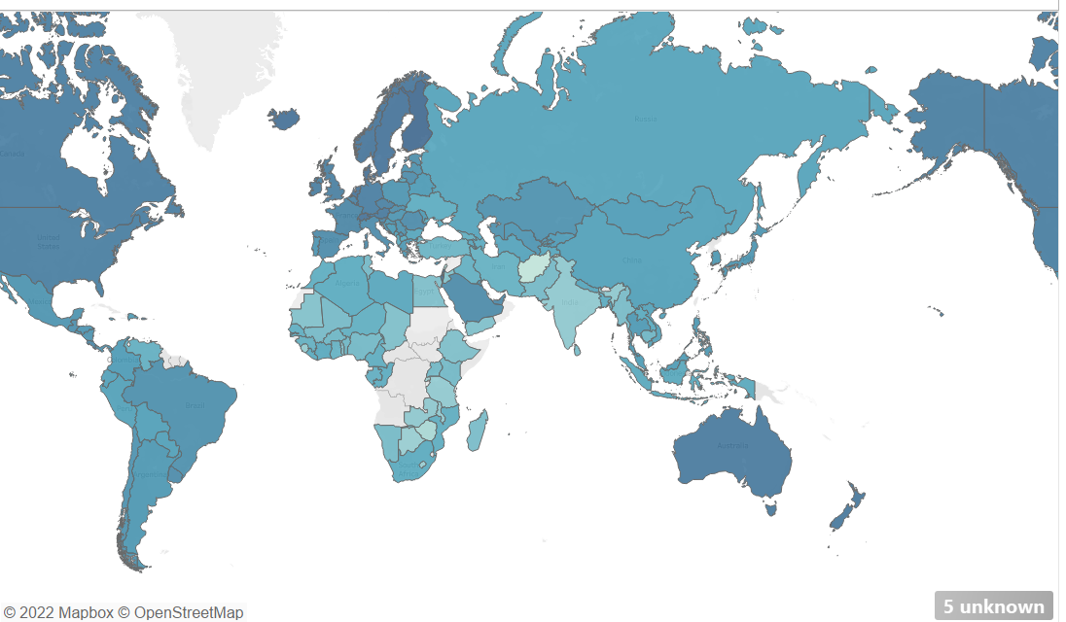

Here we can see that region in Europe, Australia and Canada have happiest country compare to Asia this is because happiness score has strong relationship with GDP and Health life and these regions has higher GDP per capita and health life.

**Result-**

* GDP, health life expectancy, and social support have high correlation with happiness score.
* India has low GDP per capita as compare Srilanka although India has high GDP but due to its high population its GDP per capita reduces.
* India was doing good in social support till 2020 after this there is drastic decrease in 2021 now we are trying to improve this.
* Health life expectancy decreases in 2019 & 2020 this is due to covid now there is increasing trend of improving.
* There is almost constant trend in generosity and perception of corruption between 2018 to 2022
* The country which are developed are more happy as compare to others.

**Conclusion-**

Happiness is a very crucial quality in everyone’s lives. It gives hope to those who need it and ensures maintenance of harmony and love among the masses. It is not just the duty of the government but us as citizens too to contribute towards the Happiness factor of our country